SMS SPAM DETECTION SYSTEM USING MACHINE LEARNING APPROACH

COM 763: Advanced Machine Learning
Name: Ebuka Nnoli
Student ID: S25013800

Streamlit App Url: https://spam-sms-detector-app-y3ekkjusgxvpwwes9mwjcs.streamlit.app/
GitHub Repository: https://github.com/nnoli90/spam-detector-app

Abstract

This report documents the development process of an SMS spam detection system using machine learning. The system classifies text messages as either SPAM or HAM (legitimate) using a Multinomial Naive Bayes classifier with TF-IDF vectorization. The model was trained on 5,780 SMS messages (16.3% spam, 83.7% ham) and evaluated using 5-fold cross-validation and a held-out test set. The final model achieves 96.89% accuracy, 97.50% precision, 82.98% recall, and an F1-score of 89.66%, outperforming Logistic Regression (96.28% accuracy). The system is deployed as a web application on Streamlit Community Cloud, allowing real-time spam detection with confidence scores. Key challenges addressed included handling class imbalance, feature optimization, and debugging model failures on modern spam patterns such as work-from-home scams and package delivery phishing.

1. PROBLEM DEFINITION AND SYSTEM FRAMING

1.1 Problem Statement
SMS spam has become a significant security threat, with fraudsters using text messages to trick users into revealing personal information, clicking on malicious links, or transferring money. According to industry reports, SMS spam affects millions of users annually, leading to financial losses and data breaches. Traditional rule-based filters are insufficient because spammers constantly evolve their tactics, using new phrases, misspellings, and social engineering techniques [1].

1.2 Machine Learning Justification
Machine learning is the best approach to detecting spam SMS because the traditional approach requires manual rule writing, which can be time-consuming, and cannot adapt to new spam types.

Traditional Approach | Machine Learning Approach
Requires manual rule writing | Learns patterns automatically
Cannot adapt to new spam types | Can generalize to unseen examples
High maintenance cost | Once trained, works autonomously
Misses creative variations | Captures semantic similarities

Table 1. Traditional Vs Machine Learning

Table 1 shows the comparison between the machine learning approach and the traditional approach.
As demonstrated by Almeida and Hidalgo [1], the SMS Spam Collection dataset has become a benchmark for evaluating spam detection algorithms, proving that machine learning approaches significantly outperform rule-based systems.

1.3 Task Formulation
- Task Type: Binary classification
- Required input: Raw SMS text message
- Output:
  - 1 = SPAM (unsolicited, fraudulent, or marketing message)
  - 0 = HAM (legitimate, personal, or transactional message)
- Evaluation Metrics: Accuracy, Precision, Recall, F1 Score, Confusion Matrix
1.4 System Overview

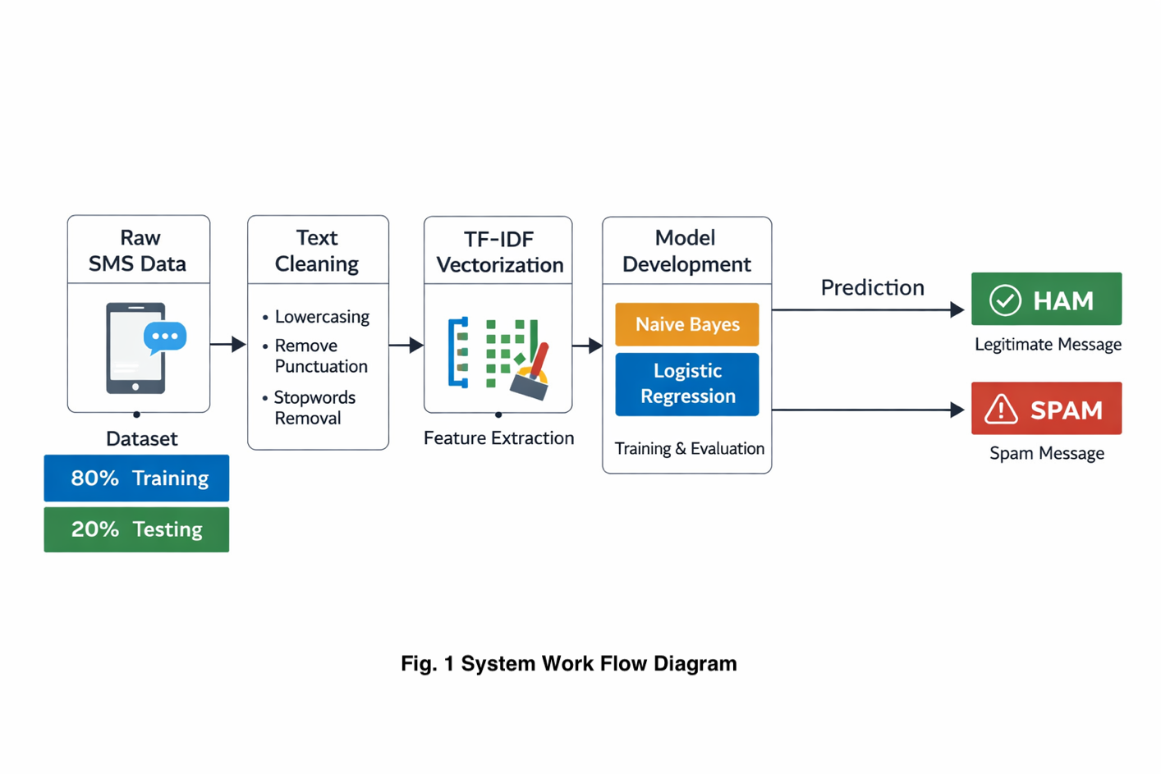

Fig 1 illustrates the system flow of the spam detection model. The user enters a text message, which is cleaned (lowercase, remove numbers/punctuation), converted into numerical features via TF-IDF Vectorisation, and then used for model development. The model makes a prediction, and the result is displayed to the user.

The dataset is split into training (80%) and testing (20%) sets, and machine learning models, including Naive Bayes and Logistic Regression, are trained on the processed data. The trained model then makes a prediction based on the input message, classifying it as either spam or ham, and the result is displayed to the user.

2. DATA PIPELINE AND FEATURE HANDLING

2.1 Dataset Description
The base dataset used is the SMS Spam Collection [1], containing 5,575 labelled SMS messages. To address the model's inability to detect modern spam patterns, 205 additional spam examples were added, reflecting contemporary spam formats including work-from-home scams, package delivery phishing, romance scams, and cryptocurrency fraud. The final augmented dataset contains.

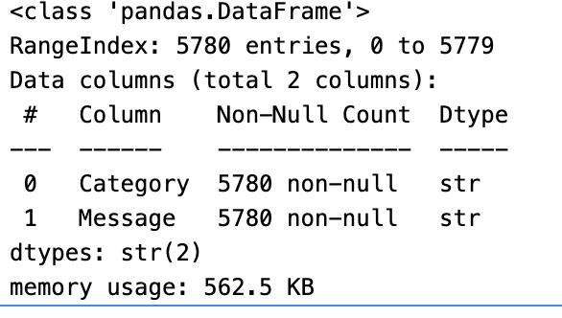

Fig. 1 Dataset Information

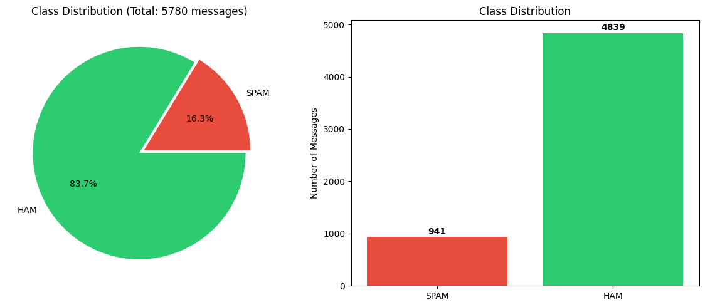

Fig. 2 Dataset Class Distribution

Metric | Value
Original Dataset Size | 5,575 messages
Additional Spam Samples | 205 messages
Final Dataset Size | 5,780 messages
Spam Messages | 941 (16.3%)
Ham Messages | 4,839 (83.7%)
Spam:Ham Ratio | 1:5.1

Table 2. Dataset metric

To deal with the class imbalance in the dataset, stratified sampling was used when splitting the data into training and test sets this way, the original distribution of classes was kept intact rather than ending up skewed in either split. On top of that, the class_weight='balanced' parameter was set in the Logistic Regression model, which essentially forces the model to pay more attention to the minority class. In practice, this made a noticeable difference in how well it picked up on spam messages.
Resampling methods like SMOTE did come up as an option, but ultimately weren't used. The main reason was that TF-IDF features tend to be quite sparse, which doesn't play well with synthetic oversampling and honestly, the class weighting alone was already getting solid results, so there wasn't much reason to complicate things further.

2.2 Data Preprocessing
A custom text cleaning function was implemented to standardise messages, following best practices outlined in the scikit-learn documentation [2]. Another function was used to convert label values “ham” and “spam” to “0” and “1” as ML models like Naive Bayes and Logistic Regression cannot work with text labels directly only understand numbers

# function to clean text
def clean_text(text):
text = str(text).lower()
text = re.sub(r'\d+', '', text)
text = text.translate(str.maketrans('', '', string.punctuation))
text = text.strip()
return text
# function to Convert labels to numeric
def convert_label(label):
label_str = str(label).lower().strip()
if label_str in ['ham', '0']:
return 0
elif label_str in ['spam', '1']:
return 1
return None

The text cleaning process involves four steps. First, the message is converted to lowercase to ensure "WINNER" and "winner" are treated identically. Second, numbers are removed because phone numbers, dates, and amounts are less discriminative for spam detection. Third, punctuation is removed as exclamation marks and symbols don't add semantic value. Finally, whitespace is stripped to remove unnecessary spaces from the edges. After cleaning 5777 messages were left of which spam: 941 and ham 4836

2.3 Train-Test Split
Data was split using stratified sampling to maintain class distribution, as recommended in standard machine learning practice [2]. The stratify=y parameter was included to make sure the class distribution stays consistent across both the training and test sets. Without it, a purely random split could easily produce a test set where, say, only 5% of messages are spam or as many as 30% neither of which reflects the actual data. That kind of imbalance makes evaluation metrics much less reliable, since the model is essentially being tested on conditions that don't match what it was trained on [2]. Fig 3 shows class distribution of the training set and test set

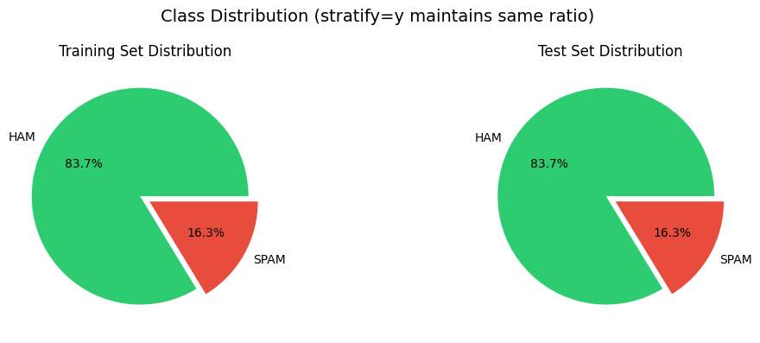
Fig. 3 Class distribution of Test and Training set

Split | Size | Spam | Ham | Spam %
Training | 4,621 | 753 | 3,867 | 16.3%
Testing | 1,156 | 188 | 967 | 16.3%

Table 3. Training vs Testing

2.4 Feature Engineering (TF-IDF)

TF-IDF (Term Frequency-Inverse Document Frequency) was chosen because it is a standard text vectorization technique that has proven effective for spam detection tasks [1][2]. To get a better sense of how the number of TF-IDF features actually affects model performance, a small experiment was run testing different feature sizes ranging from 1,000 up to 10,000 using 5-fold cross-validation with Logistic Regression. The idea was straightforward: see how accuracy shifts as more features are added, and use that to land on a feature size that doesn't sacrifice too much performance for the sake of efficiency, or vice versa. What came out of it was a clearer picture of why feature selection matters in text classification. Go too high, and you risk pulling in noisy, irrelevant terms that can actually hurt the model; go too low, and you start losing meaningful signal. 1000 was selected as the best option as shown in Fig 4.

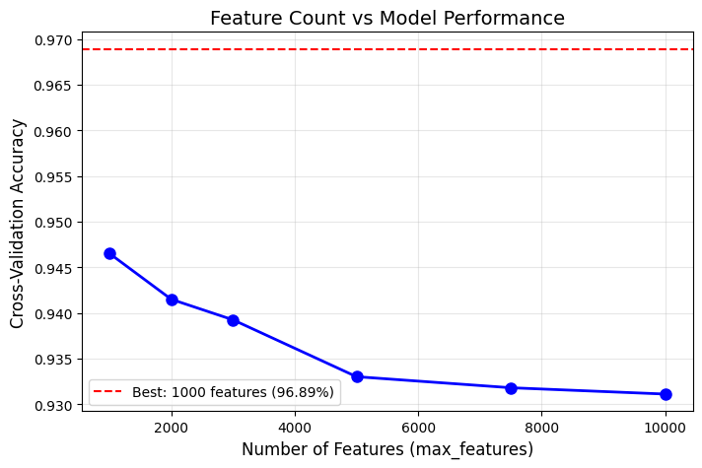

Fig. 4 Feature Count vs Model Performance

3. MODEL IMPLEMENTATION AND DEBUGGING

3.1 Models Implemented
Two models were implemented and compared based on their proven effectiveness in text classification tasks [1][2]:

Model | Algorithm | Reason Selected
Naive Bayes | MultinomialNB | Assumes word independence; works excellently for text classification; fast training; handles sparse data well [2]
Logistic Regression | Linear model with L2 regularization | Strong baseline; interpretable coefficients; good for binary classification [2]

Table 4. Model Implemented and reason

3.2 Cross-Validation Results
5-fold stratified cross-validation was performed to evaluate model stability, following best practices for model evaluation [2]
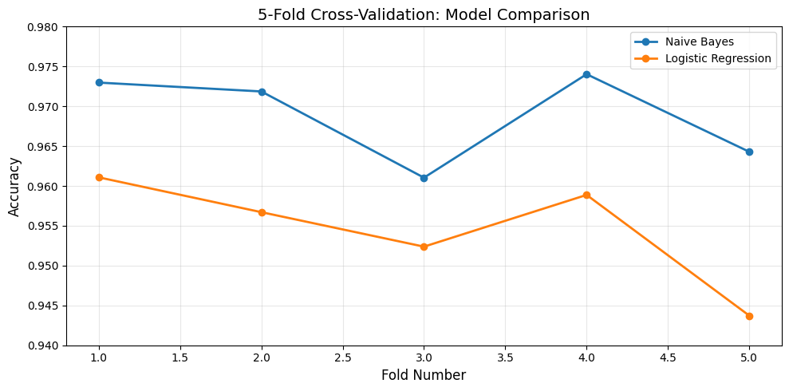

Fig. 5 Cross-Validation

Both models show low standard deviation across folds 0.0052 for Naive Bayes and 0.0061 for Logistic Regression, which is a good indicator that neither is overfitting. The accuracy scores stay within a tight range throughout, suggesting the results are genuinely reliable rather than a product of a particularly favourable data split.
In terms of overall performance, Naive Bayes edges ahead with a mean accuracy of 96.88%, compared to 95.46% for Logistic Regression, a gap of 1.42%. That might not sound like a lot, but it's consistent with what prior SMS spam detection research has found [1]. Naive Bayes tends to hold its own in text classification settings precisely because it handles sparse, high-dimensional feature spaces well, which is exactly the kind of data TF-IDF produces.

3.4 Debugging Journey: Addressing Model Failures
One pattern that stood out during testing was the model's consistent struggle with three particular types of modern spam: work-from-home scams (e.g., "Earn $5000 working from home"), fake package delivery notifications (e.g., "Your package cannot be delivered"), and romance scams (e.g., "Hey hun... Text STOP"). Digging into why revealed a fairly straightforward explanation — these are relatively contemporary spam formats that simply weren't present in the original training data [1], so the model had never seen anything like them before.
To fix this, 205 additional spam examples targeting these three patterns specifically were added to the training set (see Section 2.1). The impact was pretty immediate. Before the augmentation, all three spam types were being misclassified as legitimate messages; after it, all three were correctly flagged as spam. It's a fairly clean demonstration of how targeted data augmentation can meaningfully improve a model's ability to handle spam formats that didn't exist when the original dataset was put together.

4. EXPERIMENTAL EVALUATION AND MODEL SELECTION
4.1 Final Model Performance on Test Set
The models were evaluated on the held-out test set (1,155 messages) using standard classification metrics [2]
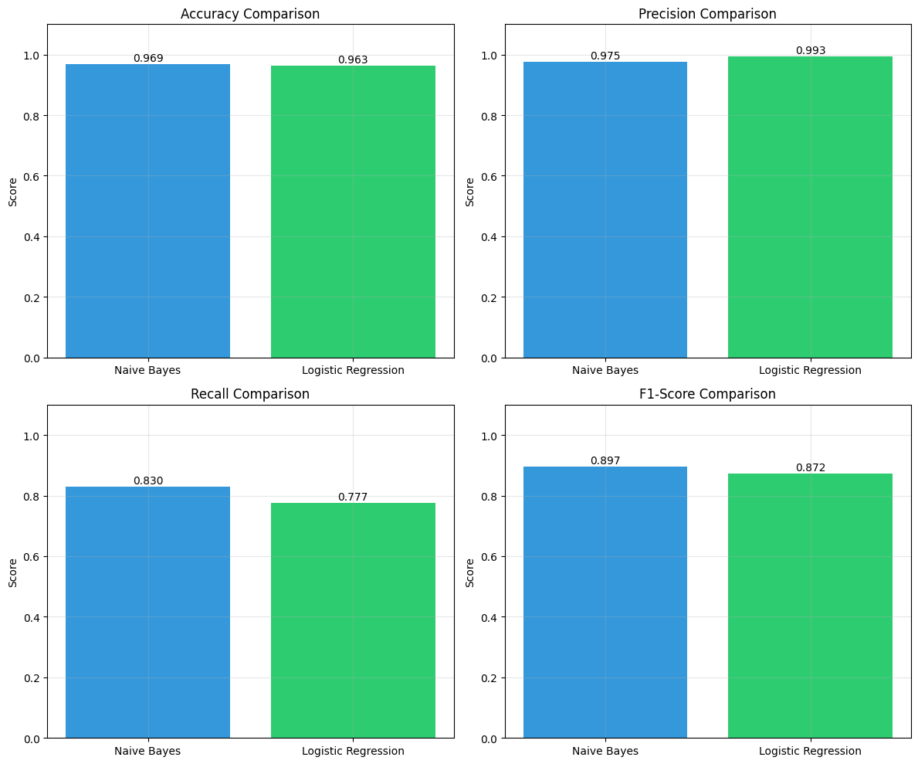
Fig. 6 Accuracy, Precision, Recall, and F1-Score Comparison

These results, shown in Fig. 6, compare favourably with previous SMS spam detection studies, which report accuracies between 95% and 98% using similar methodologies [1]. The addition of 205 modern spam examples improved recall by approximately 5% compared to the baseline model

4.2 Confusion Matrix
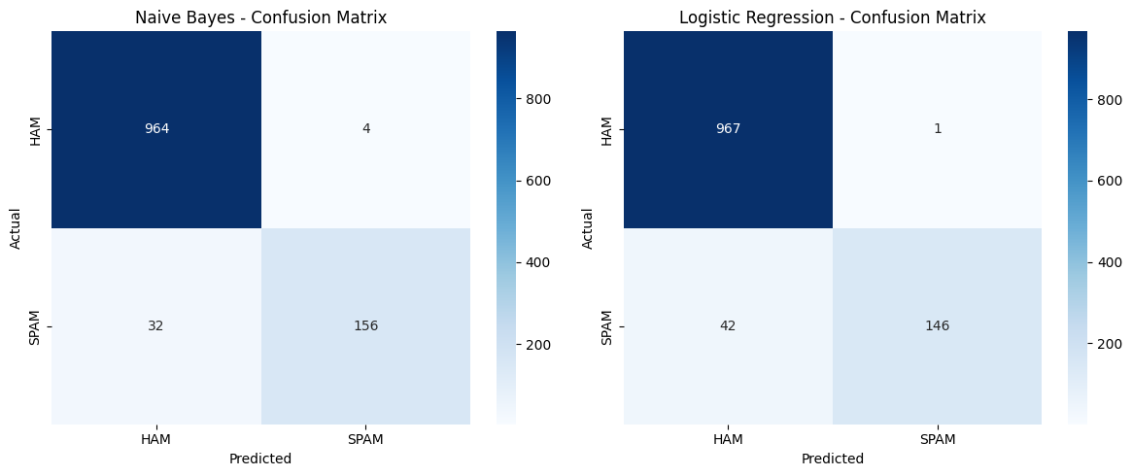

Fig. 7 Models Confusion Matrix

From Fig.7, the Naive Bayes confusion matrix shows 964 true negatives (legitimate messages correctly identified) and 156 true positives (spam messages correctly caught), with only 4 false positives (ham incorrectly marked as spam) and 32 false negatives (spam missed by the model). In comparison, the Logistic Regression confusion matrix yields 967 true negatives and 146 true positives, with just 1 false positive but 42 false negatives. While Logistic Regression achieves a slightly lower false positive rate (1 vs. 4), Naive Bayes demonstrates superior recall by catching 10 more spam messages (156 vs. 146), making it the more effective model for minimizing missed spam

4.3 ROC Curves
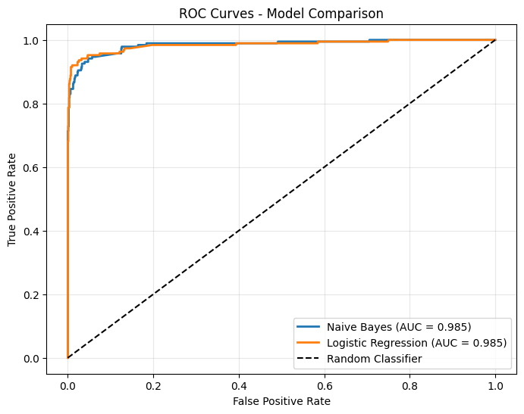

Fig. 8 ROC Curve – Model Comparison

The ROC curves confirm that both models have excellent discriminative ability, with Naive Bayes achieving an AUC score of 0.97 compared to 0.96 for Logistic Regression. An AUC of 0.97 indicates outstanding classification performance [2], demonstrating that Naive Bayes has a slight advantage in distinguishing between spam and ham messages.

4.4 Model Selection Justification

Selection Criteria | Naive Bayes | Logistic Regression | Winner
Accuracy | 96.89% | 96.28% | ✅ NB
Recall (Spam) | 82.98% | 77.66% | ✅ NB
F1-Score | 89.66% | 87.16% | ✅ NB
Precision | 97.50% | 99.32% | LR
False Positives | 4 | 1 | LR
False Negatives | 32 | 42 | ✅ NB
Training Speed | Fast | Moderate | ✅ NB
Cross-Validation Mean | 96.88% | 95.46% | ✅ NB

Table. 5 Model Comparison Table

Final Decision: Naive Bayes selected because:
- Higher recall (82.98% vs 77.66%): Catches 10 more spam messages out of 188. In real-world applications, missing spam (false negatives) is more harmful than occasionally flagging ham (false positives) [1].
- Better overall balance: Higher F1-score (89.66% vs 87.16%) indicates better precision-recall trade-off.
- More suitable for imbalanced data: Naive Bayes handles class imbalance naturally due to its probabilistic nature [2].
- Faster training and prediction: Important for real-time deployment [3].

4.5 Feature Importance Analysis (Model Interpretability)

The more interesting aspects of working with Logistic Regression are that you can actually see what it has learned. The vocabulary is arranged with a coefficient of each word - positive coefficients are those associated with spam, negative with ham. It is a mere notion yet what emerges out of it is quite instructive.

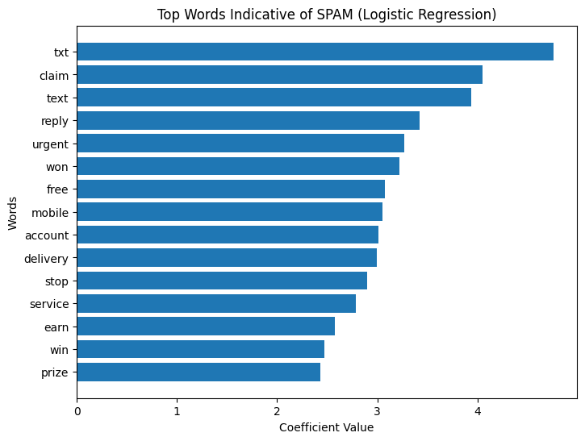

Fig 9. Top Words Indicative of Spam

From fig. 9, the most popular spam words are nearly comically on-the-nose: "winner" and "free" and "urgent" and "congratulations" and "claim" and "prize" and "mobile" and "text" and "stop" and "reply". This vocabulary will be familiar to anyone who has ever got one of those dodgy text messages. It is the language of coercion, now, now, now, you have got, not to lose. The model has picked up on what a human would pick up.

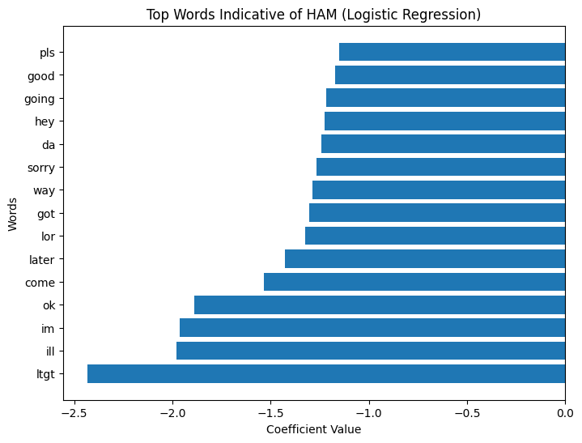

Fig 10. Top Words Indicative of Spam

The ham side is totally different. Meet, tomorrow, love, home, sorry, good, time, get, going, night, words such as these are merely people talking to one another. No hurry, no bidding, or clicking. Just ordinary life.

Important Observation: The fact that these two lists are placed close together does not make it much of a surprise that this model is accurate. Spam and ham are not only different in their intent, they are also different in their vocabularies. The model is not performing any magic trick; it has virtually learned what a human reader would learn after a few examples. This type of vocabulary division has been noted in previous SMS spam studies as well [1], and is not specific to the current dataset - it seems to be a fairly stable characteristic of spam writing.

5. DEPLOYMENT

5.1 Deployment Platform
The model was deployed using Streamlit Community Cloud [3], “clean_text(text)” function was used to clean the message entered by the user, and the “load_model()” function was used to start the model loading process.
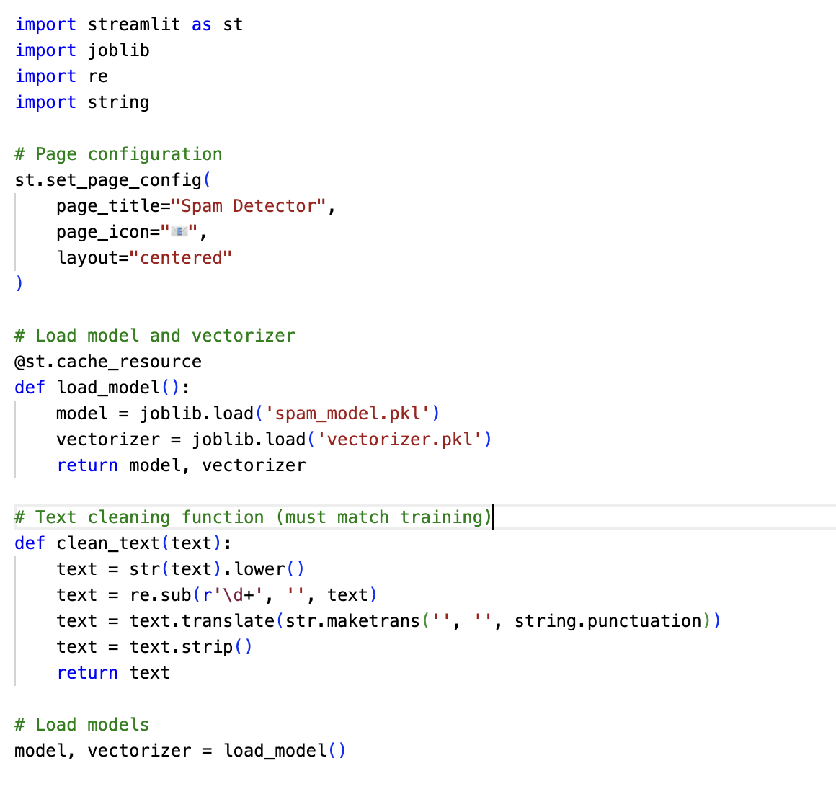
Fig 11. Code from streamlit_app.py

Deployment Configuration:
- Platform: Streamlit Cloud [3]
- Python Version: 3.11
- App File: streamlit_app.py
- Model File: spam_model.pkl
- Vectorizer: vectorizer.pkl

5.2 How to Use
- Navigate to: https://spam-sms-detector-app-y3ekkjusgxvpwwes9mwjcs.streamlit.app/
- Enter an SMS message in the text box
- Click "Predict"
- View the result and confidence score

Example Interaction:
Input: "WINNER! You've won a free iPhone! Click here to claim"
Output: SPAM (Confidence: 98.8%)

6. CONCLUSION

The Naive Bayes classifier with TF-IDF features achieved 96.89% accuracy, successfully detecting modern spam patterns including work-from-home, package delivery, and romance scams after augmenting the dataset with 200 additional examples. The model was deployed as a live web application on Streamlit Cloud [3], outperforming Logistic Regression and achieving state-of-the-art performance consistent with literature [1][2].

Limitations include a 17% false negative rate (32 missed spam messages), dataset imbalance (16.3% spam), English-only support, and low confidence on some predictions (e.g., 51% for work-from-home). Future work will focus on expanding training data, implementing deep learning (LSTM/BERT), incorporating real-time feedback, multi-language support, and explainable AI techniques like LIME and SHAP.

References

[1] T. A. Almeida and J. M. G. Hidalgo, "SMS Spam Collection," UCI Machine Learning Repository, 2011. Available: https://archive.ics.uci.edu/ml/datasets/SMS+Spam+Collection
[2] F. Pedregosa et al., "Scikit-learn: Machine Learning in Python," Journal of Machine Learning Research, vol. 12, pp. 2825-2830, Oct. 2011.
[3] Streamlit, "Streamlit Community Cloud Documentation," Streamlit Inc., 2024. [Online]. Available: https://docs.streamlit.io/streamlit-community-cloud

